**Links:**

<http://arcweb.sos.state.or.us/pages/exhibits/ww2/threat/camps.htm>

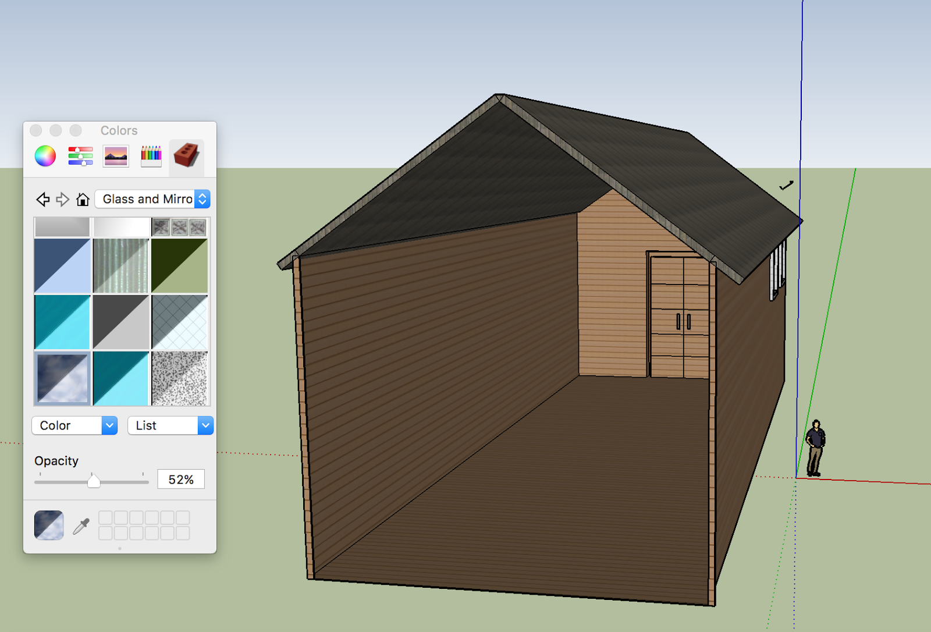

**Creating the Exterior (from scratch):**

*Note: To create the interior is to create the exterior first! It may be difficult to make sense of how SketchUp’s lines and planes connect at first, but you will learn as you experiment with the different tools and undo mistakes with the eraser tool. There should also be an instruction panel that pops up when you begin using SketchUp tools!

1. Learn to use the **Pan** (hand) tool, **Orbit** (rotation) tool, and **Zoom** and **Zoom Extents** (magnifying glass) tools to move about the screen. This will be essential to taking full advantage of SketchUp.
2. Use the **Pencil** tool to draw lines perpendicular to the blue vertical axis, in the shape of the bottom half of a house. We do not create the roof until later.
3. Continue using the pencil tool to connect the lines of the ‘house,’ thus creating planes.
4. You can now use the pencil to draw the roof, making two rectangular planes meeting in a triangle at the top as shown.
5. To make your model more three-dimensional, use the **Push/Pull** tool to add dimension as needed.
6. Use the **Paint Bucket** tool to color things in with different patterns/textures that match the corresponding feature. Anything glass/see-through can be found here under “Glass and Mirror” as well.
   1. This is how we can create the windows. After using the pencil to draw windows and layer the windows accordingly, you can easily color in the window panes with Paint Bucket using the different glass features.

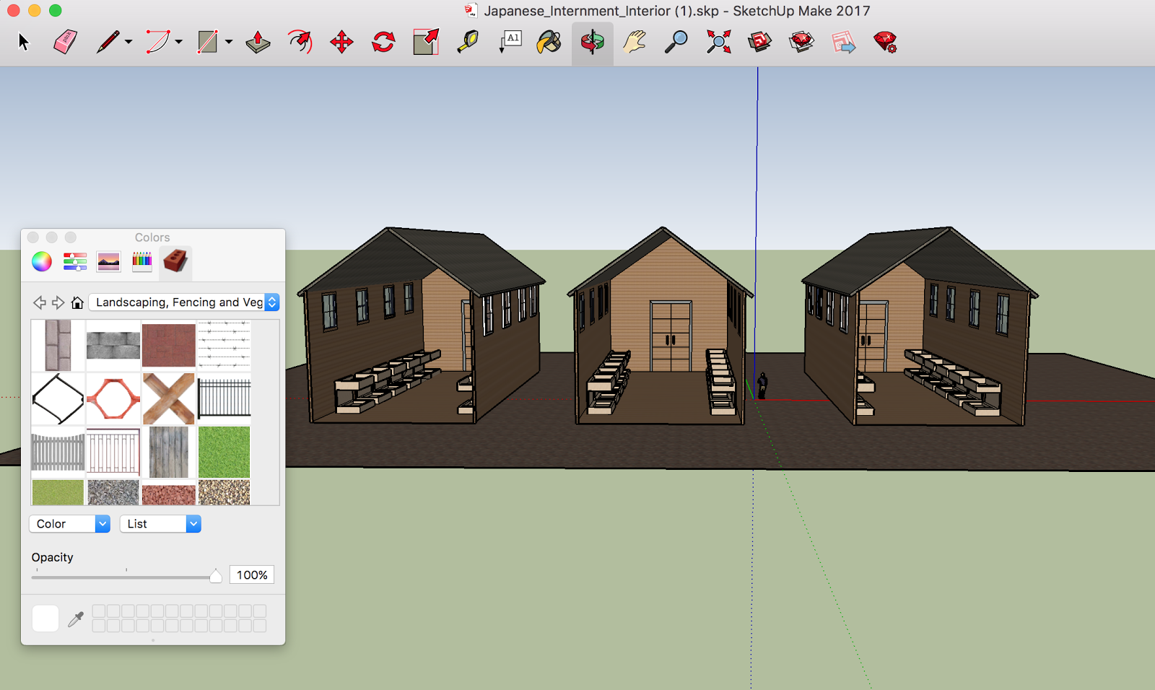

**Creating the Interior (from scratch):**

In creating the exterior, the interior is already created - you can touch it up with the Paint Bucket and making designs with the Pencil.

1. Depending on the type of Japanese Internment camp building as seen in the photos (churches, schools, homes, etc), you can design and create different pieces of furniture.
2. In the depicted example, we have three buildings with several bunk beds within.
3. To create a bunk bed, use the pencil to create a three-dimensional rectangular prism, and use the **Scale** tool to make it the right size for the little man standing outside in SketchUp.
4. You can then use **Pencil**, **Push/Pull** and **Eraser** to mold the rectangular prism into the shape of a bunk bed design of your choosing.

